1. Write a Python program to calculate the area of a rectangle given its length and width.

2) Write a Python program which accepts the radius of a circle from the user and compute the area.

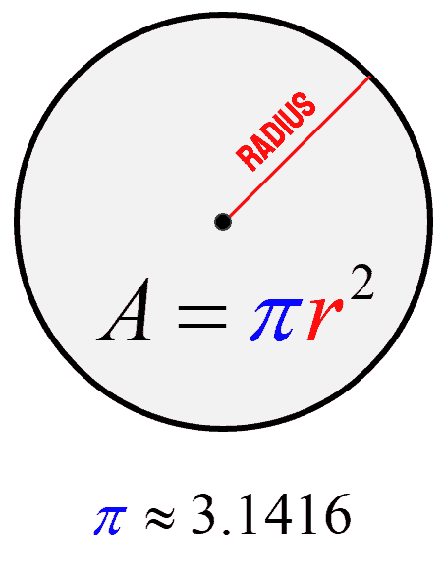

3) Convert temperature from Celsius to Fahrenheit.

4) Implement a program that converts a given number from a user of minutes into hours and minutes

5) Scenario: Optional

Your task is to complete the code in order to evaluate the following expression:

The result should be assigned to y. Be careful ‒ watch the operators and keep their priorities in mind. Don't hesitate to use as many parentheses as you need.

You can use additional variables to shorten the expression (but it's not necessary). Test your code carefully.

